Tylor-made solutions-report template.doc
Report template
This template is to help you to indicate possible NbS solutions to improve the adaptiveness of the investigated areas such as cities or districts or streets. To do it fill the gaps with the knowledge you acquired using IMPETUS measurements methodologies, but also you got from the internet and field observation. You will need the access to climate scan database. See the example of the tailor-made solutions for Groningen, the Netherlands and Gdansk in Poland.
Step 1 Description of the investigated area
Table 1. Area description.
Name of the area (cities or district or street)
Reference to climatescan.nl database project
Investigated area topography
(described if the terrain is on slope, flat, you can add cross-sections or map to present the land shape).
Investigated area land development
(describe the intensity – low in suburbs and high in the city centre). Upload pictures, or photomaps print screens, sketches.

Step 2 Climate change effects and generated problems
Identify climate change effects that tackle the investigated area and describe main problems. Do research on online resources, use the results from the IMPETUS measurements and field observation. Mind that not all problems presented in the Table 2 may be present in your area.
Table 2. Climate change effects/problems.
Climate change effect | Description
The urban heat island effect
Loss of biodiversity
Flooding
Heavy precipitation
Climate extremes
Loss of water quality and quantity
Hot spells/heat waves
Droughts
Rising sea level
Plastic pollution
Air pollution
Step 3 Generate the DNA of the city
The instruction how to generate city DNA you will find in ClimateScan instruction.pdf. Shortly comment the results, focusing on the NbS solutions, that are implemented in the city to mitigate and adapt to climate changes. Remember that climatescan.nl database is a narrative map and data are not reviewed, but if they are added to your own research and acquired data their analysis is beneficial and can add value to the area land development at the early stage analysis.
Step 4 The review of the NbS
Look through the set of NbS solutions presented in the table below or directly from the database climatescan.nl. You can also visit https://www.urbangreenbluegrids.com/measures/ for more inspiration on NbS.

Table 3. NbS solutions (climatescan.nl).
 | Symbol | Picture /  Link ClimateScan category | Name (English)
bioswale | 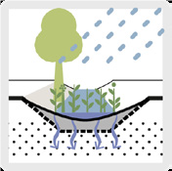 | 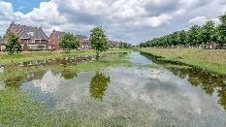  More examples on: https://www.climatescan.org/#filter-1-1 | A bioswale is a ditch with vegetation, a porous bottom and below that a layer of gravel, packed in geotextile with an infiltration pipe/drainpipe. It allows rainwater storage, infiltration and transport while helping to enhance biodiversity and quality of life.
green roofs |  | 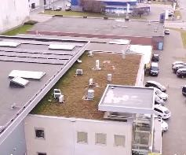  Category green roofs > 400 examples  More examples on:  https://www.climatescan.org/#filter-1-4 | A green roof is a multi-layered roof system that is partially or entirely covered with vegetation. Extensive green roofs have a maximum depth of six inches and are a layered system containing growing media, waterproofing membrane, drainage, and often irrigation components. Extensive green roofs can support groundcovers and shallow root plant material, and therefore require less structural support and reduced maintenance when compared to intensive roofs
green facades | 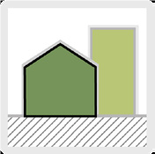 | 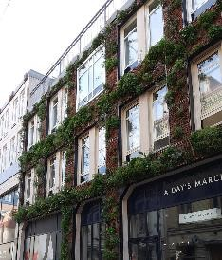  Green facades  More examples on:  https://climatescan.org/#filter-1-121 | Green facades attract and lose heat. The plants also cause evaporation, which helps keeping the town or city’s climate cooler. An advantage is that it takes up little space in an already intensively used urban area, while providing many vertical square metres of green.
raingardens | 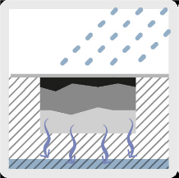 | 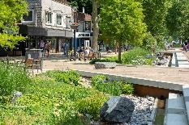  More examples on:  https://climatescan.nl/#filter-1-65 | Raingardens are sandy soil or aggregate filled depressions that treat stormwater runoff to improve water quality. Stormwater is captured and allowed to percolate through the soil/ aggregate layer, where pollutants are removed,  prior to being released through an underdrain located at the bottom of the depression.
Create extra surface water (m²) | 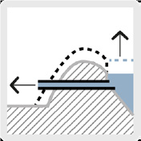 | 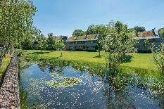  Water storage  More examples on:  (https://climatescan.nl/#filter-1-44) | Create extra surface water (m²)  Realising additional surface area for storage can serve to create additional storage volume while the fluctuation in water level remains unchanged. Part of the standard fluctuation of 30 cm, for example, is then earmarked for seasonal storage, while the other part is reserved for peak storage. The advantage to this method of seasonal storage is that the fluctuations are limited, which is good for flora along the banks.
Infiltration field and strips, with surface storage | 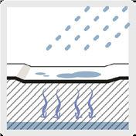 | 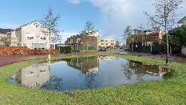  Water storage  (https://climatescan.nl/#filter-1-43)  Also see bio swales | Infiltration field and strips with surface storage  Adding fields next to paved surfaces to temporarily store runoff is a simple way to allow water to infiltrate from clean hard surfaces such as roofs and cycle paths. Besides the volume of precipitation that needs buffering, the permeability of the ground is another factor that deter-mines the minimum dimensions.
Specific seasonal storage facility | 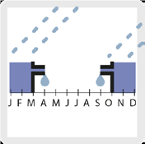 | 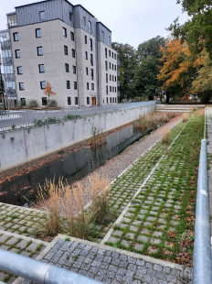  Water storage and infiltration  (https://climatescan.nl/#filter-1-44)  Water storage  (https://climatescan.nl/#filter-1-100)  and  (https://climatescan.nl/#filter-1-43)  Ponds  (https://climatescan.nl/#filter-1-43-85)  Water storage rural/urban zone  (https://climatescan.nl/#filter-1-43-16) | Specific seasonal storage facility  Specific seasonal storage facilities can be used to balance water shortage in dry periods and surplusses in wet periods. Seasonality often leads to periods of drought and periods of excessive rainfall. This leads to imbalanced water availability as water usage remains stable throughout the year. Consequently, water abundances are often followed by water shortages. To reduce water shortages in the dry season, it is necessary to store a maximum amount of water during the wet season. Besides large scale measures like dams and major water retention lakes, there are also measures which function on a smaller scale, such as tanks underneath buildings, small lakes within the city, on roofs, water squares or simply a water tank alongside the house.

Step 5 Tylor-made solutions
Decide which NbS solutions can be implemented. Point out their location (you can add GPS coordinates, or indicate the location on the print screen of any area map). Explain your choice for each NbS solutions, be critical, show prons and cons of the discussed proposals.
Table 4. Tylor-made solutions.
NbS solution (name, link to the example in database, GPS coordinates or number on the map which you need to upload) | Discussion on your choice. What are the benefits of this NbS solution, which problem it solves, why this location is appropriate etc.
Example #1: Tylor-made solutions - Groningen
Step 1 Description of the investigated area
Table 5. Area description.
Name of the area (cities or district or street) | Groningen
Reference to climatescan.nl database project | https://www.climatescan.nl/projects/180/detail

 | There are over 100 projects in the Groningen municipality listed in ClimateScan
Investigated area topography  (described if the terrain is on slope, flat, you can add cross-sections or map to present the land shape). | 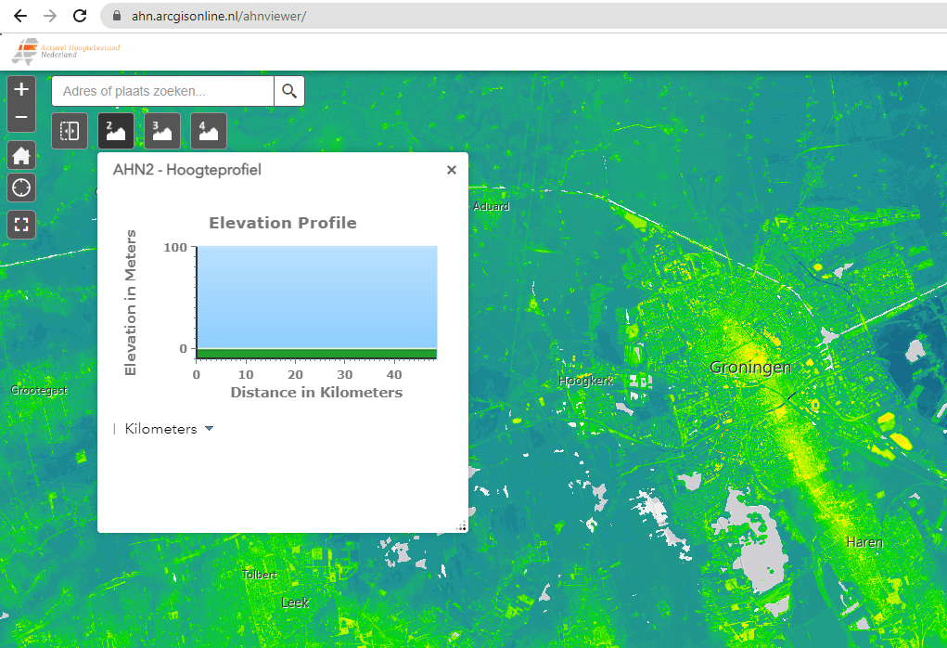  Groningen is located in the North of The Netherlands and is a relatively flat city as presented in the Figure above which shows the elevation in the city close to 0 (data and map viewer from Current Height File of The Netherlands (AHN), www.ahn.nl)
Investigated area land development  (describe the intensity – low in suburbs and high in the city centre). Upload, add pictures, ortofotomaps print screens, sketches | Land development is high throughout the city. In Groningen you see many old buildings. Also, most dwellings were built in the beginning of the 20th century. Most of the surface is covered from buildings or streets. Impermeable pavement is implemented in many cases to infiltrate the runoff surface water.  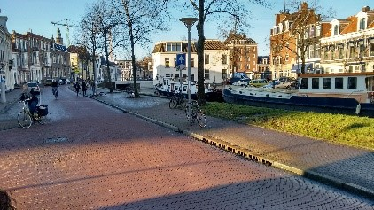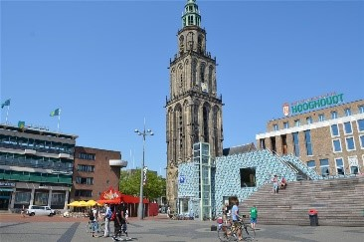  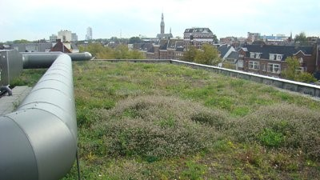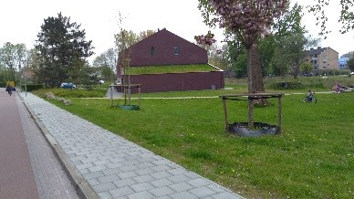  Photos from climatescan.nl
Step 2 Climate change effects and generated problems
Identify climate change effects that tackle the investigated area and describe main problems. Do research on online resources, use the results from the IMPETUS measurements and field observation. Mind that the problems presented in the Table below may not be present in your area.

Table 6. Climate change effects/problems.
Climate change effect | Description
The urban heat island effect | 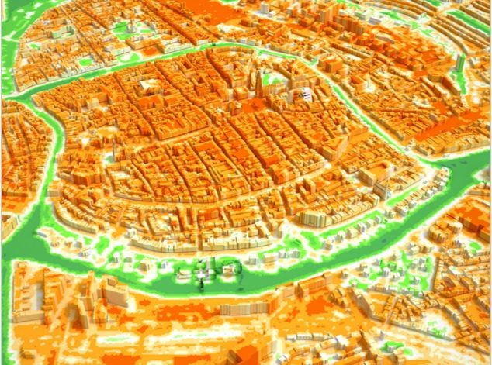  Groningen Urban Heat island  Groningen is an old city and there is not much vegetation within the neighbourhoods. The Figure above shows the urban heat island effect in a 3D color map where the orange colour interprets for higher temperatures.
Loss of biodiversity
Flooding | Groningen is in The Netherlands a country that was built from reclamation of land space by pushing the sea further away and thus the possibility of flood is always high. In addition to the low ground elevation and the dense population the possibility of flooding in Groningen increases.  https://www.youtube.com/watch?v=EwGEOkS0rgc  https://northerntimes.nl/heavy-rainfall-hits-northern-netherlands-flooding-several-towns/

Heavy precipitation | With climate change it is expected that precipitation will increase resulting in more frequent flooding events as well. The Figure below shows the amount of rainfall for a 24 hours period during a heavy rainfall in Groningen in July 2010. The red dot is the area of Groningen city.  www.knmi.n
Climate extremes
Loss of water quality and quantity
Hot spells/heat waves
Droughts
Rising sea level
Plastic pollution
Air pollution

Step 3 Generate the DNA of the city
The instruction how to generate city DNA you will find in ClimateScan instruction.pdf. Shortly comment the results, focusing on the NbS solutions, that are implemented in the city to mitigate and adapt to climate changes. Remember that climatescan.nl database is a narrative map and data are not reviewed, but if they are added to your own research and acquired data their analysis is beneficial and can add value to the area land development at the early stage analysis.

Figure 1. DNA of the city.
With climate change the temperature and precipitation are expected to increase. Climate adaptation measures are of high importance in order to mitigate the effects of climate change. The DNA of the city of Groningen shows that climate adaptation is present in Groningen. Around 100 projects have been listed in the ClimateScan map viewer in the municipality of Groningen including among others many green roofs/ walls, bioswales and permeable pavements.
Step 4 The review of the NbS
Look through the set of NbS solutions presented in the Table 3 or directly from the database climatescan.nl You can also visit https://www.urbangreenbluegrids.com/measures/ for more inspiration on NbS.
Step 5 Tylor-made solutions
Decide which NbS solutions can be implemented. Point out their location (you can add GPS coordinates, or indicate the location on the print screen of any area map). Explain your choice for each NbS solutions, be critical, show prons and cons of the discussed proposals.
Table 7. Tylor-made solutions.
NbS solutions (name, link to the example in database, GPS coordinators or number on the map which you need to upload) | Discussion on your choice. What are the benefits of this NbS solution, which problem it solves, why this location is appropriate etc.
Permeable pavement in Zernike campus  (more details: http://www.climatescan.nl/projects/9897/detail)  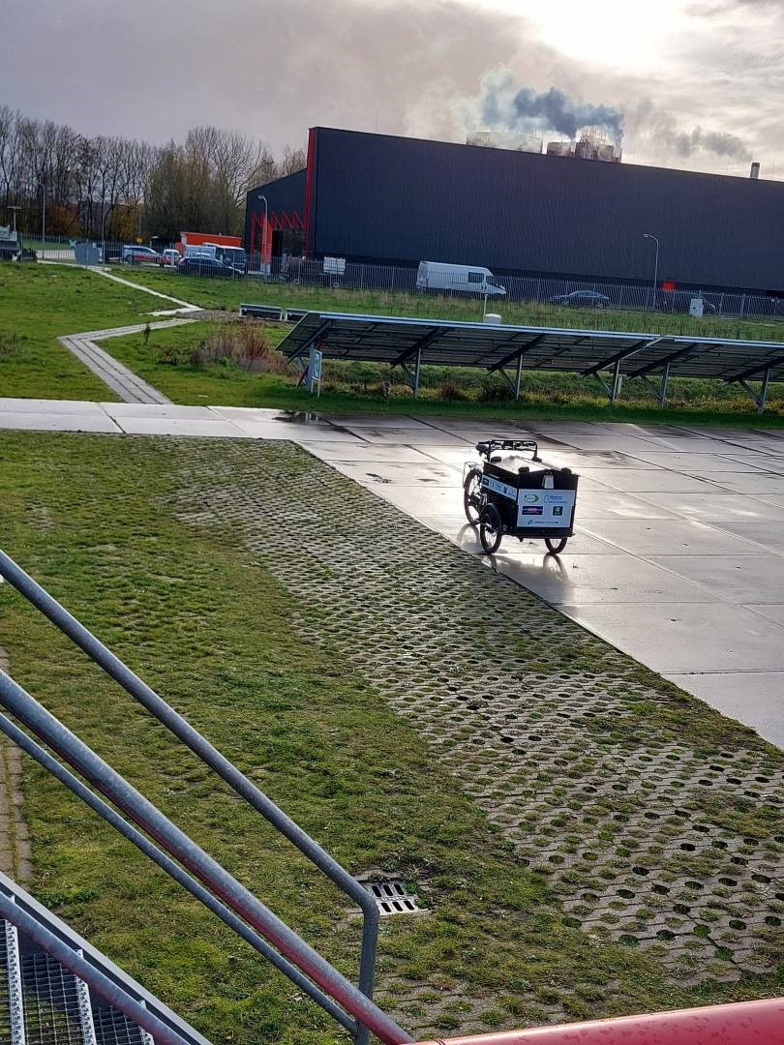 | Permeable pavement helps with the infiltration of surface water. It helps to reduce the risk of flooding events. Permeable pavements are very common throughout Groningen.
Green roof  (more info:  https://www.climatescan.nl/projects/1177/detail)  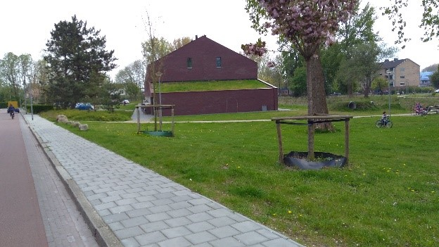 | The green roof serves multiple purposes on a building. It is capable of absorbing rainwater, creating a habitat for small animals and insects besides the beautiful aesthetic to the surrounding area and the people.  The vegetation on the green roof helps towards the urban heat island effect by contributing to lower the air temperature.  This green roof is located nearby a bike street in Groningen.

Biodiversity in Groningen  (more info:  https://www.climatescan.nl/projects/6448/detail)  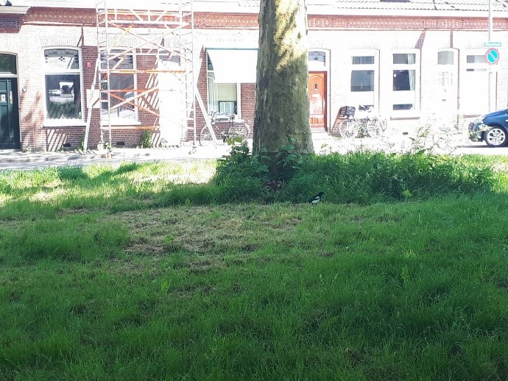 | There are many small green spaces spread in the city of Groningen and 2 large city parks. This creates a habitat for many birds, ducks and geese increasing the biodiversity in an urban environment.

Example #2: Tylor-made solutions - Gdansk
Step 1 Description of the investigated area
Table 5. Area description.
Name of the area (cities or district or street) | Gdansk
Reference to climatescan.nl database project | https://www.climatescan.nl/projects/4441/detail

Investigated area topography  (described if the terrain is on slope, flat, you can add cross-sections or map to present the land shape). | 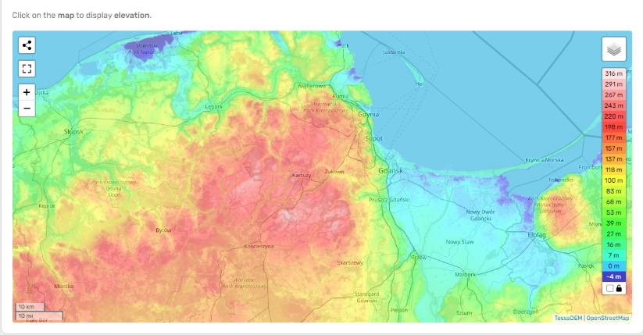  Fig. Topography of Gdańsk (en-ca-topographic-map.com)  Gdansk is a coastal city in the Baltic Sea. It is the main seaport of Poland and it lays next to the Gradova hill. The city is mainly flat with low elevation as it is presented in the elevation map from the World topographic map in the Figure above.
Investigated area land development  (describe the intensity – low in suburbs and high in the city centre). Upload, add pictures, ortofotomaps print screens, sketches | Gdansk is an old and historical city. Many of the buildings were built in the last century. The closer you get to the centre of the city urbanization gets higher and green spaces decrease.
Step 2 Climate change effects and generated problems
Identify climate change effects that tackle the investigated area and describe main problems. Do research on online resources, use the results from the IMPETUS measurements and field observation. Mind that the problems presented in the Table below may not be present in your area.
Table 6. Climate change effects/problems.
Climate change effect | Description
The urban heat island effect | Dark surfaces absorb more sunlight increasing the urban heat island effect in urbanized areas.  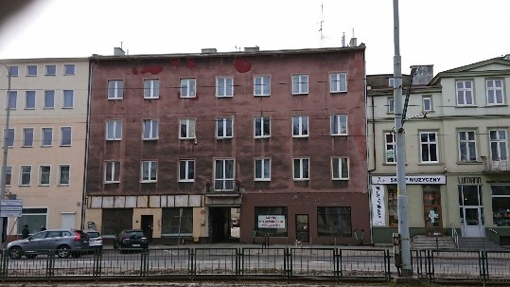  Photo from climatescan.nl
Loss of biodiversity | The lack of green spaces and vegetation results in the absence of biodiversity and wildlife around.  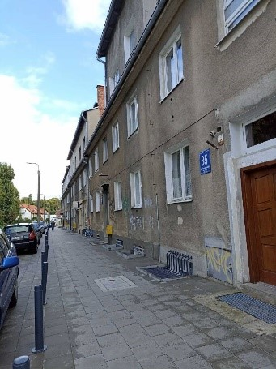  Photo from climatescan.nl  More information:  https://www.climatescan.nl/projects/9512/detail
Flooding | Untreated rainwater that falls on the built areas and not permeable pavements increases the possibility of flooding.
Heavy precipitation
Climate extremes
Loss of water quality and quantity
Hot spells/heat waves
Droughts
Rising sea level
Plastic pollution
Air pollution

Step 3 Generate the DNA of the city
The instruction how to generate city DNA you will find in ClimateScan instruction.pdf. Shortly comment the results, focusing on the NbS solutions, that are implemented in the city to mitigate and adapt to climate changes. Remember that climatescan.nl database is a narrative map and data are not reviewed, but if they are added to your own research and acquired data their analysis is beneficial and can add value to the area land development at the early stage analysis.
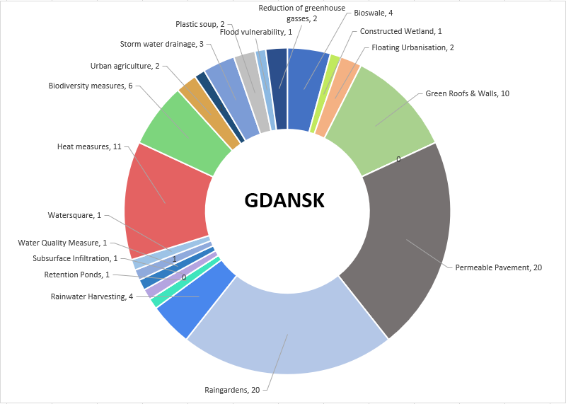
Figure 2. DNA of the city.
The DNA of the city of Gdansk shows the climate adaptation measures in Gdansk. Precipitation is intermediate in Gdansk and the city lies in the mouth Motława River which is a branch of the Vistula River. The city centre of the city is historical with not many green spaces. There is plenty of water in Gdansk and flood mitigation measures are needed there to avoid the surplus of surface water. Approximately 100 projects have been listed in the ClimateScan map viewer in the Gdansk area including among others many raingardens and permeable pavements.
Step 4 The review of the NbS
Look through the set of NbS solutions presented in the Table 3 or directly from the database climatescan.nl You can also visit https://www.urbangreenbluegrids.com/measures/ for more inspiration on NbS.

Step 5 Tylor-made solutions
Decide which NbS solutions can be implemented. Point out their location (you can add GPS coordinates, or indicate the location on the print screen of any area map). Explain your choice for each NbS solutions, be critical, show prons and cons of the discussed proposals.
Table 7. Tylor-made solutions.
NbS solutions (name, link to the example in database, GPS coordinators or number on the map which you need to upload) | Discussion on your choice. What are the benefits of this NbS solution, which problem it solves, why this location is appropriate etc.
Raingarden  (more details: http://www.climatescan.nl/projects/4441/detail)  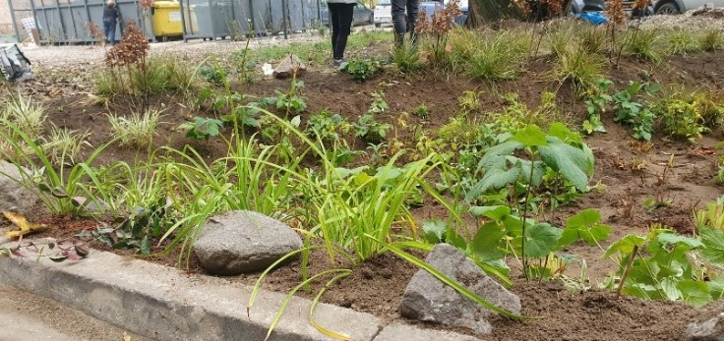 | Raingardens help with the infiltration of the surface water. Apart from the beautiful aesthetics of the environment they also help to prevent urban flooding.
Creating small green spaces in urban environments  (more info:  https://www.climatescan.nl/projects/6073/detail)  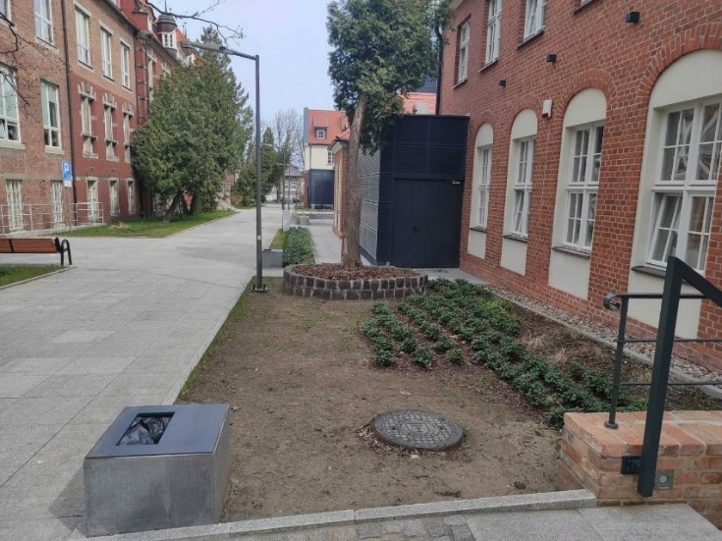 | Green spaces help the urban environment in many ways. They can be created even in small spaces, here between two buildings in the campus in Gdansk. Green spaces can increase biodiversity, help to reduce the urban heat island effect and provide nice aesthetics to the surrounding area. They also help to infiltrate the surface water.

Collecting rainwater in barrels  (more info:  https://www.climatescan.nl/projects/9508/detail)  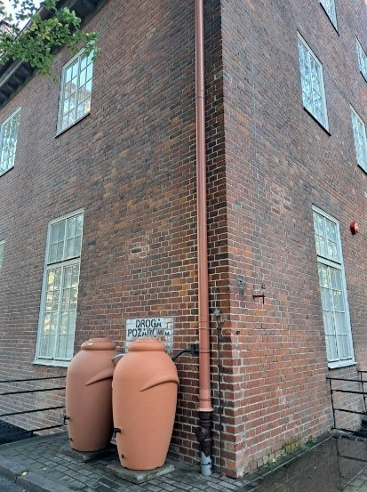 | Collecting the rainwater that falls from buildings in barrels helps to prevent flooding. This measure helps to also reuse the rainwater for irrigation purposes.

Most of the uploaded projects belong to categories related to NBS, SuDS, WSUD and BMPs that are designed to reduce the rate and quantity of surface water runoff from developed areas and to improve runoff water quality. Uploads on climatescan.nl include: constructed wetlands, bio swales, green roofs and walls, permeable pavements, rainwater gardens and floating structures on public and private property. Along with uploading climate adaptation measures, problem areas are also mapped, where solutions can be implemented.
Most of the uploaded projects belong to categories related to NBS, SuDS, WSUD and BMPs that are designed to reduce the rate and quantity of surface water runoff from developed areas and to improve runoff water quality. Uploads on climatescan.nl include: constructed wetlands, bio swales, green roofs and walls, permeable pavements, rainwater gardens and floating structures on public and private property. Along with uploading climate adaptation measures, problem areas are also mapped, where solutions can be implemented.
Boogaard, Floris & Vojinovic, Zoran & Chen, Yu-Cheng & Kluck, Jeroen & Lin, Tzu Ping. (2016). High Resolution Decision Maps for Urban Planning: A Combined Analysis of Urban Flooding and Thermal Stress Potential In Asia and Europe. MATEC Web of Conferences. 103. 10.1051/matecconf/201710304012.
Most of the uploaded projects belong to categories related to NBS, SuDS, WSUD and BMPs that are designed to reduce the rate and quantity of surface water runoff from developed areas and to improve runoff water quality. Uploads on climatescan.nl include: constructed wetlands, bio swales, green roofs and walls, permeable pavements, rainwater gardens and floating structures on public and private property. Along with uploading climate adaptation measures, problem areas are also mapped, where solutions can be implemented.

